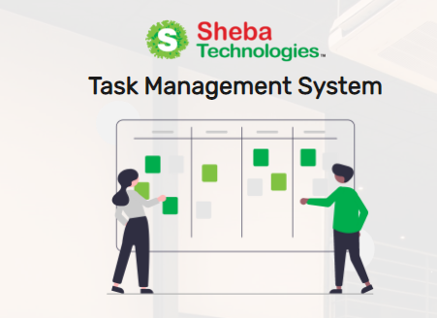

**Task Management System (TMS)**

***Application User Manual***

Document Version 1.0

07 November 2021

**Disclaimer**

This guide has been validated and reviewed for accuracy. The instructions and descriptions it contains are accurate for Task Management System application. However, succeeding versions and guides are subject to change without notice.

**Revision History**

|  |  |  |  |
| --- | --- | --- | --- |
| **Revision No.** | **Created/Updated By** | **Release Date** | **Comments** |
| 1.1 | A S M Lutful Kabir | 09 November 2021 | 1st Release |

**Table of Contents**

[1 About the Solution 6](#_Toc89620193)

[2 Purpose of this Guide 6](#_Toc89620194)

[3 Typographical Conventions 6](#_Toc89620195)

[4 Application Channel 6](#_Toc89620196)

[5 Login 7](#_Toc89620197)

[5.1 User Login 7](#_Toc89620198)

[5.2 Invalid Email / Password 8](#_Toc89620199)

[5.2.1 Forget Password 8](#_Toc89620200)

[6 Navigation Bar 9](#_Toc89620201)

[7 Dashboard 11](#_Toc89620202)

[7.1 Assign New Task 13](#_Toc89620203)

[7.1.1 Create New Task (Assigner Module) 14](#_Toc89620204)

[7.1.2 Accept New Task (Assignee Module) 18](#_Toc89620205)

[7.1.3 Reject Features & Request in Task 19](#_Toc89620206)

[7.2 Propose Task Button 20](#_Toc89620207)

[8 Task Analytics 23](#_Toc89620208)

[8.1 Overall Task Status 23](#_Toc89620209)

[8.2 Program Wise Details 24](#_Toc89620210)

[8.2.1 Overdue Task Status 24](#_Toc89620211)

[8.2.2 Overall Task Status 25](#_Toc89620212)

[8.2.3 Programme Task Details 25](#_Toc89620213)

[9 Tasks 26](#_Toc89620214)

[10 Task Approvals 27](#_Toc89620215)

[11 Proposed Tasks 28](#_Toc89620216)

[12 User Management 29](#_Toc89620217)

[12.1 All User List 29](#_Toc89620218)

[12.2 Add New User 30](#_Toc89620219)

[12.3 Edit User 32](#_Toc89620220)

[12.4 Bulk Upload 33](#_Toc89620221)

[13 Role Management 34](#_Toc89620222)

[13.1 All Role List 34](#_Toc89620223)

[13.2 Create Role 35](#_Toc89620224)

[13.3 Edit Role 36](#_Toc89620225)

[14 Report Generate 37](#_Toc89620226)

[15 Notification Module 38](#_Toc89620227)

**List of Figures**

[Figure 1 Login Page 7](file:///C:\Users\Sheba\OneDrive\Desktop\Desktop\TMS_User_Manual_%20V-1.docx#_Toc89620228)

[Figure 2 Invalid Login 8](file:///C:\Users\Sheba\OneDrive\Desktop\Desktop\TMS_User_Manual_%20V-1.docx#_Toc89620229)

[Figure 3 Reset Password Page 8](file:///C:\Users\Sheba\OneDrive\Desktop\Desktop\TMS_User_Manual_%20V-1.docx#_Toc89620230)

[Figure 4 Navigation Bar 9](file:///C:\Users\Sheba\OneDrive\Desktop\Desktop\TMS_User_Manual_%20V-1.docx#_Toc89620231)

[Figure 5 User Dashboard 11](file:///C:\Users\Sheba\OneDrive\Desktop\Desktop\TMS_User_Manual_%20V-1.docx#_Toc89620232)

[Figure 6 Assign a New Task 13](file:///C:\Users\Sheba\OneDrive\Desktop\Desktop\TMS_User_Manual_%20V-1.docx#_Toc89620233)

[Figure 7 Create New Task Form 14](file:///C:\Users\Sheba\OneDrive\Desktop\Desktop\TMS_User_Manual_%20V-1.docx#_Toc89620234)

[Figure 8 New Task Create 16](file:///C:\Users\Sheba\OneDrive\Desktop\Desktop\TMS_User_Manual_%20V-1.docx#_Toc89620235)

[Figure 9 New Task Details Page 16](file:///C:\Users\Sheba\OneDrive\Desktop\Desktop\TMS_User_Manual_%20V-1.docx#_Toc89620236)

[Figure 10 All Task List (Assignee Module) 18](file:///C:\Users\Sheba\OneDrive\Desktop\Desktop\TMS_User_Manual_%20V-1.docx#_Toc89620237)

[Figure 11 Update Task Status 18](file:///C:\Users\Sheba\OneDrive\Desktop\Desktop\TMS_User_Manual_%20V-1.docx#_Toc89620238)

[Figure 12 Request Menu 19](file:///C:\Users\Sheba\OneDrive\Desktop\Desktop\TMS_User_Manual_%20V-1.docx#_Toc89620239)

[Figure 13 Proposed Task Form 20](file:///C:\Users\Sheba\OneDrive\Desktop\Desktop\TMS_User_Manual_%20V-1.docx#_Toc89620240)

[Figure 14 Task Creation Message 21](file:///C:\Users\Sheba\OneDrive\Desktop\Desktop\TMS_User_Manual_%20V-1.docx#_Toc89620241)

[Figure 15 Proposed task Deletion (Assignee) 22](file:///C:\Users\Sheba\OneDrive\Desktop\Desktop\TMS_User_Manual_%20V-1.docx#_Toc89620242)

[Figure 16 Proposed Task List 28](file:///C:\Users\Sheba\OneDrive\Desktop\Desktop\TMS_User_Manual_%20V-1.docx#_Toc89620243)

[Figure 17 All User list (1) 29](file:///C:\Users\Sheba\OneDrive\Desktop\Desktop\TMS_User_Manual_%20V-1.docx#_Toc89620244)

[Figure 18 All User List (2) . 29](file:///C:\Users\Sheba\OneDrive\Desktop\Desktop\TMS_User_Manual_%20V-1.docx#_Toc89620245)

[Figure 19 Create New User Page 30](file:///C:\Users\Sheba\OneDrive\Desktop\Desktop\TMS_User_Manual_%20V-1.docx#_Toc89620246)

[Figure 20 Edit User Page 32](#_Toc89620247)

[Figure 21 Bulk Upload Page 33](file:///C:\Users\Sheba\OneDrive\Desktop\Desktop\TMS_User_Manual_%20V-1.docx#_Toc89620248)

[Figure 22 Role Management Page 34](#_Toc89620249)

[Figure 23 Add New Role Page 35](file:///C:\Users\Sheba\OneDrive\Desktop\Desktop\TMS_User_Manual_%20V-1.docx#_Toc89620250)

[Figure 24 Edit Role Page 36](file:///C:\Users\Sheba\OneDrive\Desktop\Desktop\TMS_User_Manual_%20V-1.docx#_Toc89620251)

[Figure 25 Report generate page 37](file:///C:\Users\Sheba\OneDrive\Desktop\Desktop\TMS_User_Manual_%20V-1.docx#_Toc89620252)

[Figure 26 Notification Module page 38](file:///C:\Users\Sheba\OneDrive\Desktop\Desktop\TMS_User_Manual_%20V-1.docx#_Toc89620253)

**List of Tables**

[Table 1 User Login Page Details 7](#_Toc89620254)

[Table 2 Navigation bar details 10](#_Toc89620255)

[Table 3 User Dashboard Page Details 12](#_Toc89620256)

[Table 4 Create New Task Form details 15](#_Toc89620257)

[Table 5 New Task Page Details 17](#_Toc89620258)

[Table 6 Request in Task Page Details 19](#_Toc89620259)

[Table 7 Proposed Task Form details 21](#_Toc89620260)

[Table 8 All User list Table details 30](#_Toc89620261)

[Table 9 Create New User Page Details 31](#_Toc89620262)

[Table 10 Edit User Page Details 32](#_Toc89620263)

[Table 11 Bulk Upload Page Details 33](#_Toc89620264)

[Table 12 Role Management Page Details 34](#_Toc89620265)

[Table 13 Add New Role Page details 35](#_Toc89620266)

[Table 14 Edit Role Page details 36](#_Toc89620267)

[Table 15 Report generate page details 37](#_Toc89620268)

[Table 16 Notification Page details 39](#_Toc89620269)

# About the Solution

Task Management System can improve the employee productivity and monitor the progress of any assigned project, task for the individual and team. Task Management System will enable to properly track and manage the task s)/project(s) in an efficient manner.

The proposed solution will be wrapped with some essential’s features and functionalities through automation and monitoring.

This guide will enable you to use every option of the TMS solution application and provides detailed procedures. Based on the user’s role, all the user will not get similar features and functions that are available in the system.

# Purpose of this Guide

This document describes the functional and system level features of TMS application. This document contains overview of the application.

*User***:** The primary user for this application who are categorized as:

* + Users/Assignees
  + Supervisors/Team Leads
  + System Admin

# Typographical Conventions

|  |  |
| --- | --- |
| **Type Face** | **Meaning** |
| **Bold** | Used to indicate buttons on the screen. |
| *Italic* | Used as special instructions/actions/notes and reference to other sections. |

# Application Channel

The application will be used by intended user on their PC / Laptop/ Mobile Phone via web browser.

# Login

Figure 1 Login Page

* This is the Login Page for the user.

## User Login

* For a general user admin have to create a user profile of that respective user in the system.Then the login panel will allow the user to access the application via their designated PIN & password.

Table 1 User Login Page Details

|  |  |
| --- | --- |
| **Field Name / Button** | **Description** |
| **Email** | Enter relevant email address, in the Email field. |
| **Password** | Enter relevant password in the Password field |
| **LOGIN** | Click to login |

## Invalid Email / Password

* 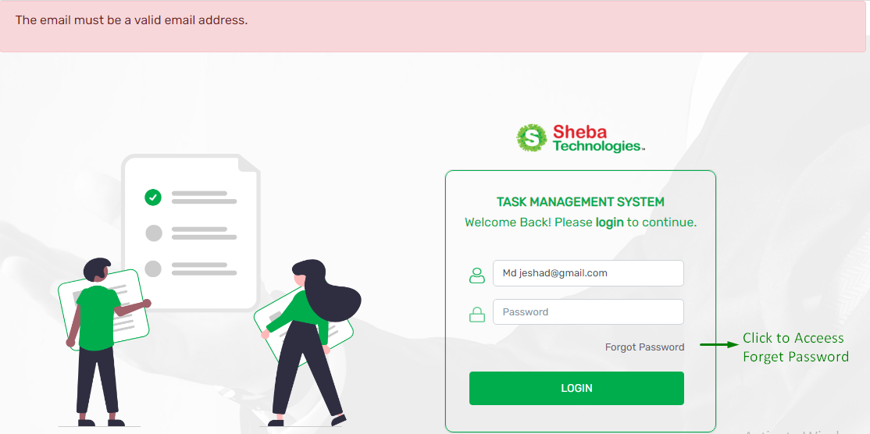If the user enters invalid email or password then the system will show unauthorized access to the user.

Figure 2 Invalid Login

### Forget Password

Figure 3 Reset Password Page

* Clicking on Forget password button will redirect to reset password page.
* Here user have to enter relevant user Email Address of the user.
* By clicking on Send Password Reset link button, user will get a password reset link in their given email address

# Navigation Bar

* From the Navigation Function Users will be able to access Dashboard, Task, Task Approvals, Proposed Tasks, User Management, Role Management, New Task, Propose Task Button, New Team and Time & Date Features.
* Permission of the Navigation is limited depending on the access control of the User.

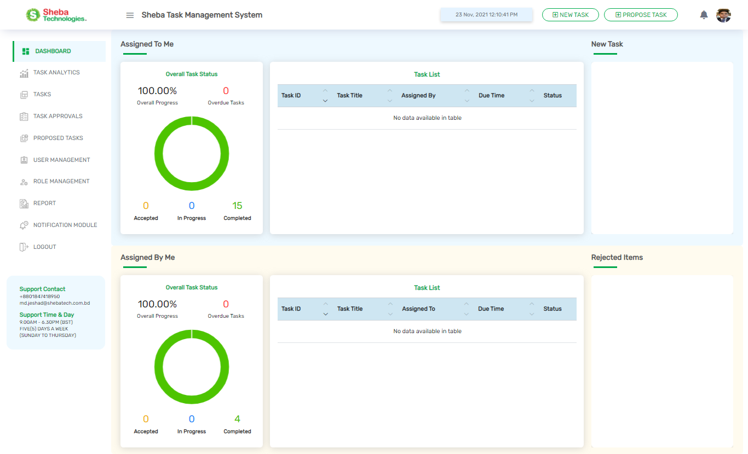

**Click To Access Task Analytics**

**Click To Access Task**

**Click To Access**

**Notification Module**

**Click To Access**

**Report Generate**

**Click To Logout**

**Click To Access Task Approvals**

Figure 4 Navigation Bar

**Click To**

**Access Proposed Task**

**Click to**

**Access Role Management**

**Click To Access User**

**Management**

**Click To Create New Task**

**Click**

**To Access Proposed Task page**

Table 2 Navigation bar details

|  |  |
| --- | --- |
| **Field Name/Button** | **Description** |
| **Dashboard** | Clicking on the button will redirect user to Dashboard Page. |
| **Task Analytics** | Clicking on the button will redirect user to Overall Task Status Page. |
| **Task** | Clicking the button will redirect user to All Task List Page. |
| **Task Approvals** | Clicking on the button ,user will redirect to All Proposed task list page |
| **Proposed Task Page** | Clicking on the button will redirect the user all the proposed task page |
| **User Management** | Clicking the button will redirect user to All User List Page. |
| **Role Management** | Clicking the button will redirect user to All Role List Page. |
| **Logout** | Prompt the user to logout and redirect user to Login Page. |
| **Report** | Clicking on the button user will be redirect to Report generate Page. |
| **Notification Module** | Clicking the button will redirect user to All Event List Page. |
| **Propose Task Button** | Clicking on the button, user will be redirected to Propose Task from. |
| **New Task Button** | Clicking on the button will redirect to Create New Task .form |

# Dashboard

The Dashboard is divided into two section, which are as follows:

* **Assigned To Me**

1. **Overall Task Status**: View the status of the task that are assigned to the user.
2. **Task List**: View the task information which are assigned to the user.
3. **New Task**: New task that are requested to the user.

* **Assigned By Me**

1. **Overall Task Status**: View the overall status of the task that are assigned by the user.
2. **Task List**: View the task information which are assigned by the user.
3. **Rejected Items**: Displays assigned task which are rejected and requested by assignee users.

* **New Task View Card**
* **Rejected Items View Card**

Figure 5 User Dashboard

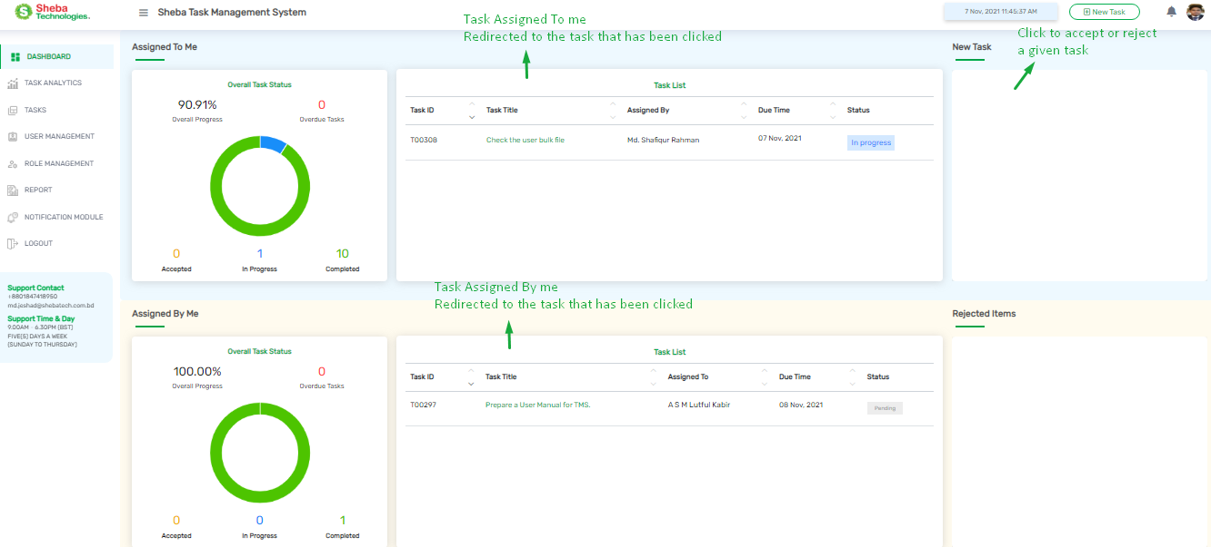

Table 3 User Dashboard Page Details

|  |  |
| --- | --- |
| **Column/Field Name/Button** | **Description** |
| **Task Assigned To Me** | User can click the task that are assigned to the user, to view the task detail |
| **Assigned by** | Name of the respective user who assigned the task |
| **Task Assigned By Me** | User can click the task that are assigned by the user, to view the task detail |
| **Assigned To** | Name of the respective user who will assigned for the task |
| **Task ID** | Relevant Id of Task |
| **Task Title** | Title of the Task |
| **Due Time** | Due date / time of the task |
| **Status** | Status of the relevant task |
| **New Task (View Card)** | User can click the task in the new task, to accept or reject the task |
| **Rejected Items (View Card)** | User can click the task from the rejected items, to reassign rejected task to other user or accept requests |

## Assign New Task

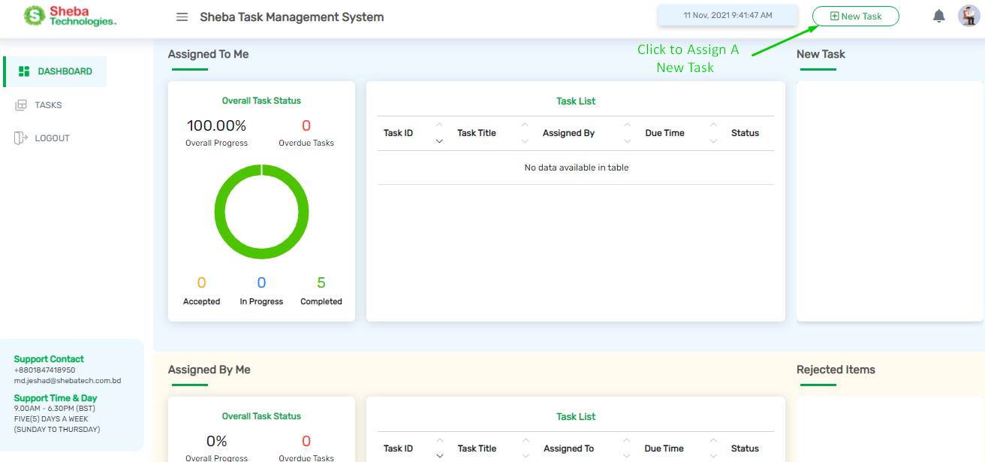

Figure 6 Assign a New Task

* Clicking on the New Task button user will redirect to Create New Task page.
* Here user will find a form for assigning a task to a designated person

### Create New Task (Assigner Module)

Figure 7 Create New Task Form

* Here user will find few fields, buttons Description box.
* Clicking on Save button will assign a new task.
* Clicking on Cancel button will close the form

Table 4 Create New Task Form details

|  |  |
| --- | --- |
| **Field Name/Button** | **Description** |
| **Task Title** | Title of the relevant task. |
| **Description box** | Enter description for the relevant. |
| **Assign To Individual** | Here search with the keywords and put check mark on the check box, and assign the task to a relevant assignee. |
| **Start Date** | Select relevant start date for the task. |
| **End date** | Select relevant end date for the task |
| **Priority** | Select priority level (High / Medium / Low) from the dropdown menu |
| **Attachments** | By clicking on Attachments button user will be able to attach relevant file and documents for the task. |
| **Comments** | Enter relevant comments for the task |
|  | By clicking on the button user will be able to assign a new task |
|  | By clicking on the button user will be able to close the Create New Task form |

* 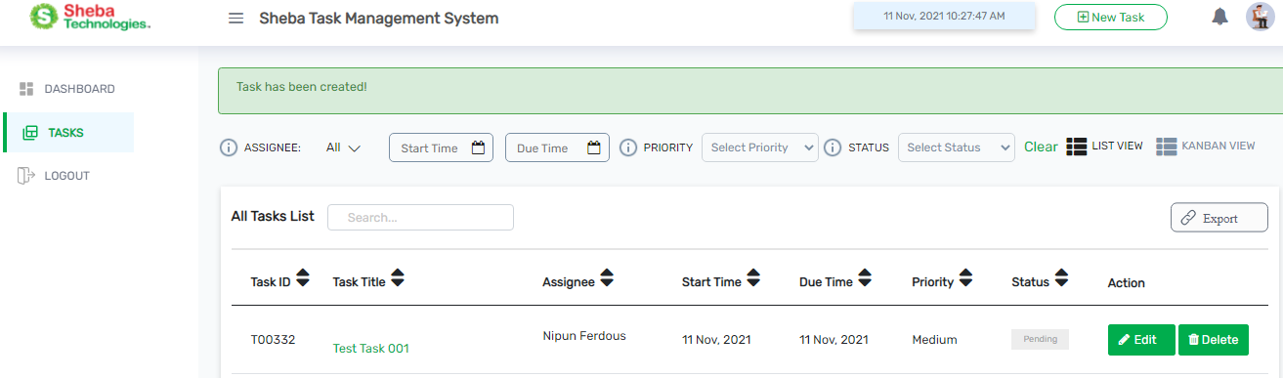After assigning a task user will see a confirmation message (Task has been created) on the top of All Task List page

Figure 8 New Task Create

* Assignee will get a notification in the web application and also at their relevant email.
* Here user can Edit or Delete a assigned task from the Action column
* 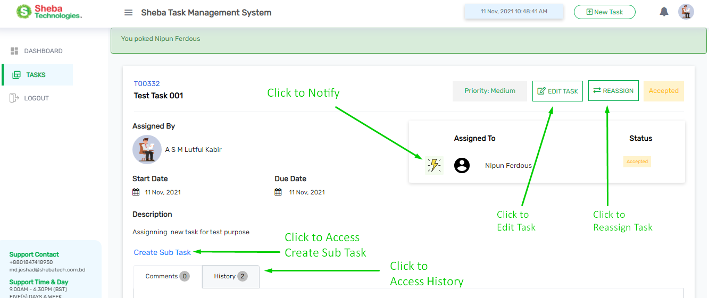Clicking on the relevant task from the All task list table, user will redirect to the Task Details page

Figure 9 New Task Details Page

* Here user can perform this following actions
* Edit task,
* Reassign task
* Notify the assignee (Nudge button)
* Acceptance status
* Create Sub Task of that task
* Comments / History about the task

Table 5 New Task Page Details

|  |  |
| --- | --- |
| **Field Name/Button** | **Description** |
| **Assigned By** | Name of the person who assigned the task. |
| **Assigned To** | Designated person for the task |
| **Status** | Acceptance status of the task. |
| **Edit Task** | Edit the relevant task. |
| **Reassign** | Reassign to task to another person. |
| **Description** | Description about the relevant task. |
| **Create Sub Task** | Clicking on this user will be able to create sub task. |
| **History** | Click to access history. |
| **Comments** | Here user can add comments in the task. |
| **Priority level** | Priority level of the relevant task |
| **Nudge Button** | Clicking on the button notify the designated person for the task. |

### Accept New Task (Assignee Module)

* 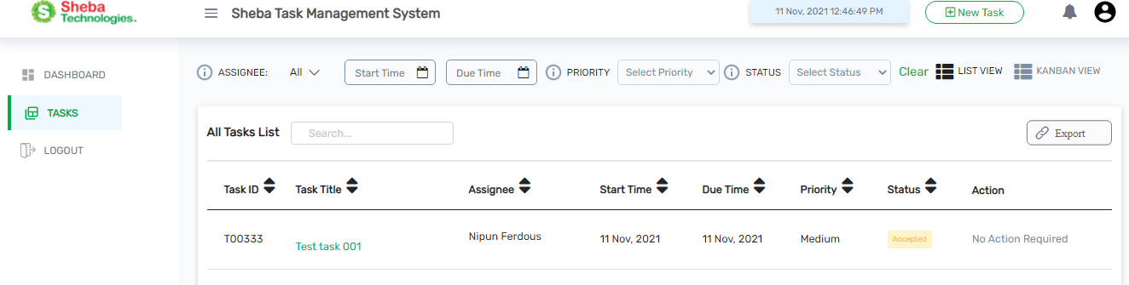User can see the assigned task from the Task menu, as well as from the dashboard.

Figure 10 All Task List (Assignee Module)

* Clicking on Accept or Reject button, user will be able to accept or reject a task.
* Clicking on relevant task user will redirect to details page of that task.

#### Update Task Status

* 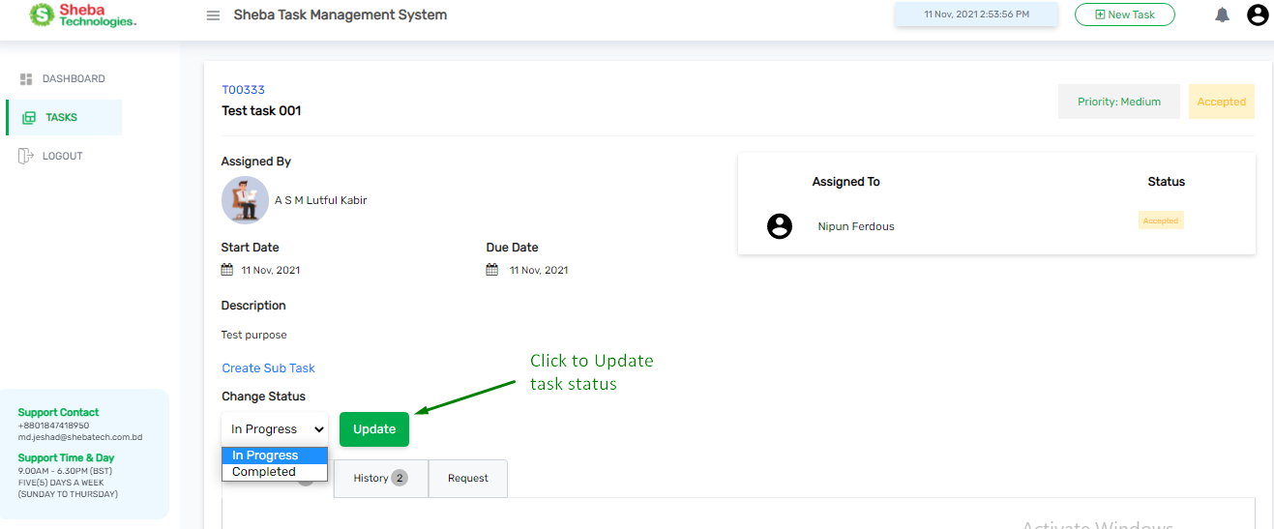In this page user will find all the details about the Task.

Figure 11 Update Task Status

* From Change Status drop down user can change the task status, then user have to click update button to update status of the task.
* User can add comments about a task, check history about the task.

### Reject Features & Request in Task

* Clicking on **Reject** button user will be able be redirect to **Request For** menu.
* User can **reject a task** using first three dropdown options. Here user also can request by using other three dropdown options.
* 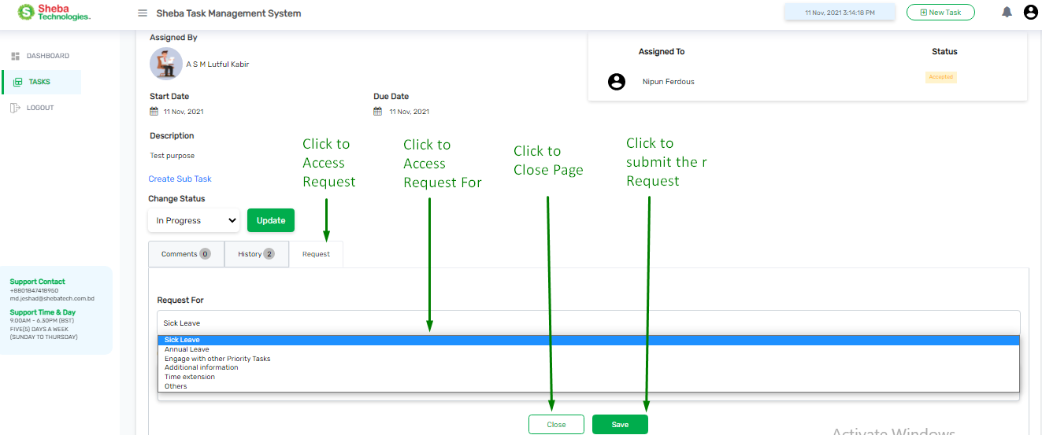Clicking on Save button user will be able submit the request.

Figure 12 Request Menu

* Clicking on Close button user will be able to close the form.
* Designated user can also reject a Task.

Table 6 Request in Task Page Details

|  |  |
| --- | --- |
| **Field Name/Icon/Button** | **Description** |
|  | Enables admin to search for any keyword; |
|  | User can go back and forth of pages by clicking Next/Previous buttons. |
|  | User can decide to view the number of entries of total skills from this drop down list at the bottom left corner of this page. |
|  | Click to generate report. |

## Propose Task Button

* Clicking on the **Propose Task button** user will redirect to proposed task form

**Click to Access Propose Task**

Figure 13 Proposed Task Form

* 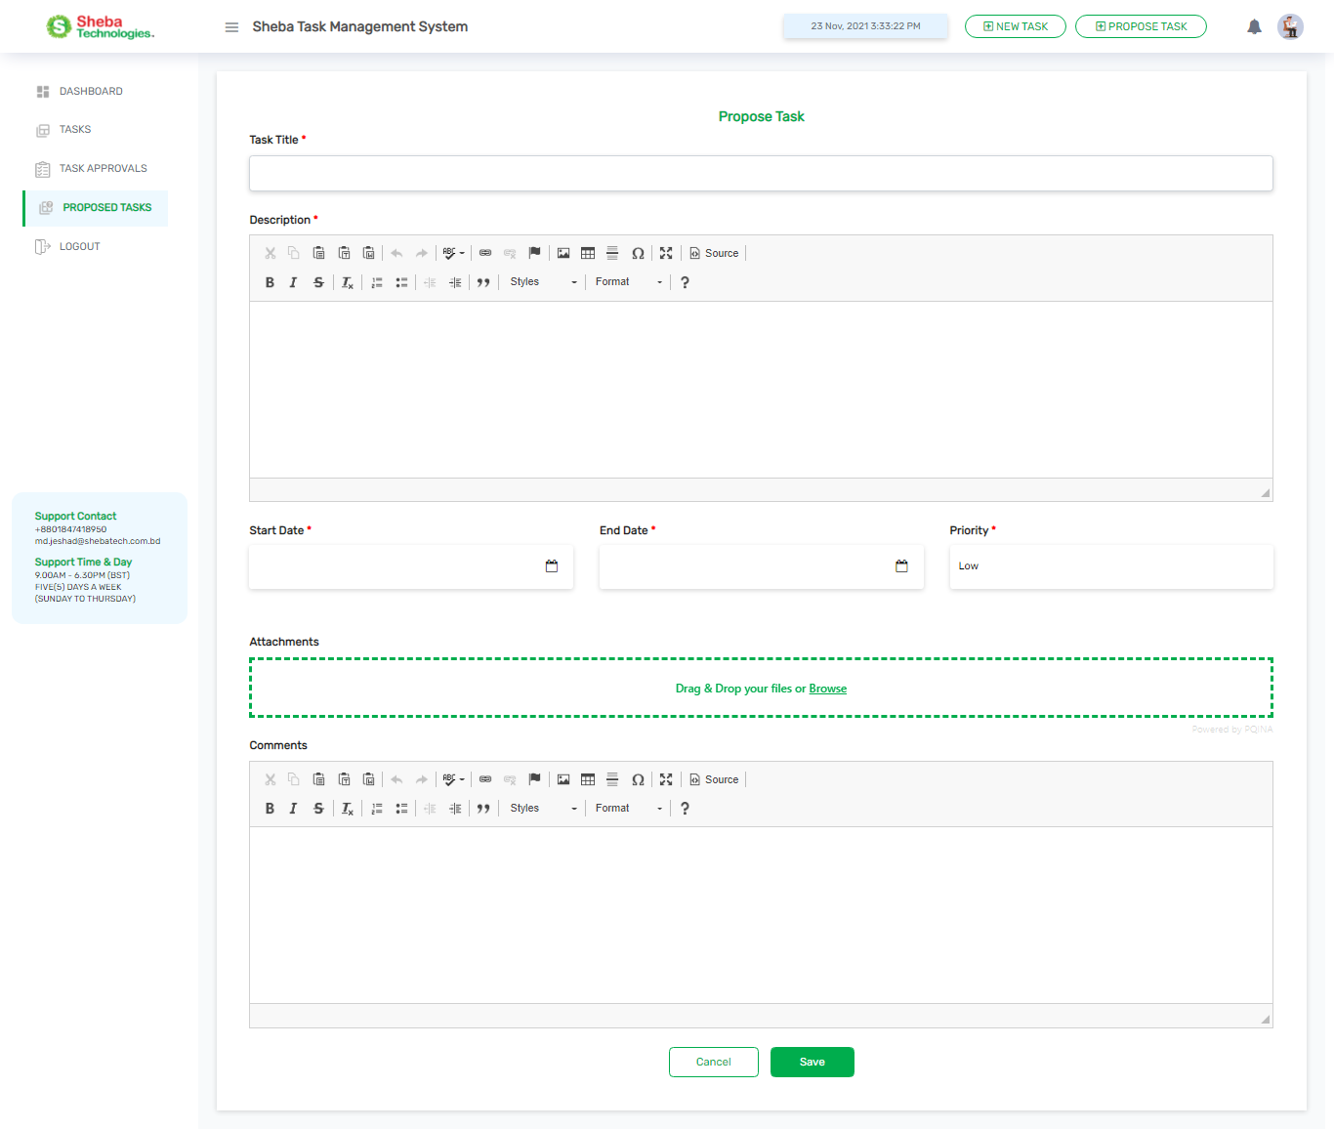After proposing a task user can **Edit** it or **Delete** it until the designated line manager **Accept** or **Reject** it.
* Once the line manager complete his/her action, then line manager will have the task deletion permission.

|  |  |
| --- | --- |
| **Column/Field Name/Button** | **Description** |
| **Task Title** | Enter Title of the Task |
| **Description** | Enter relevant Description of that task |
| **Start Date / End Date** | Enter Relevant Start date and End date for that task |
| **Priority** | Set relevant priority from the drop down (High/ Medium / Low ) |
| **Attachments** | Click to Attach relevant files for the task |
| **Comments** | Enter relevant comments for the task |
| **Status** | Status of the relevant task |
|  | Clicking on save button will submit the proposed task to line managers Task approvals page for acceptance. |
|  | Clicking on cancel button will close the form |

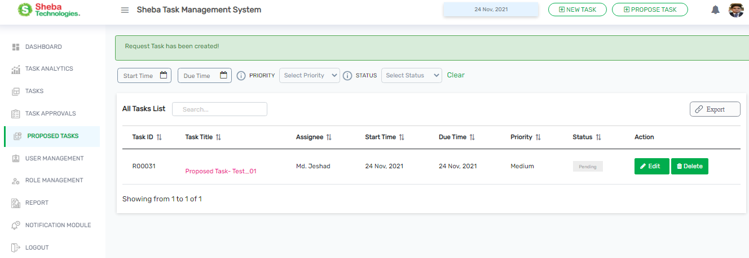Table 7 Proposed Task Form details

Figure 14 Task Creation Message

* After proposing a task following message will be shown: **Request Task has been created.**
* 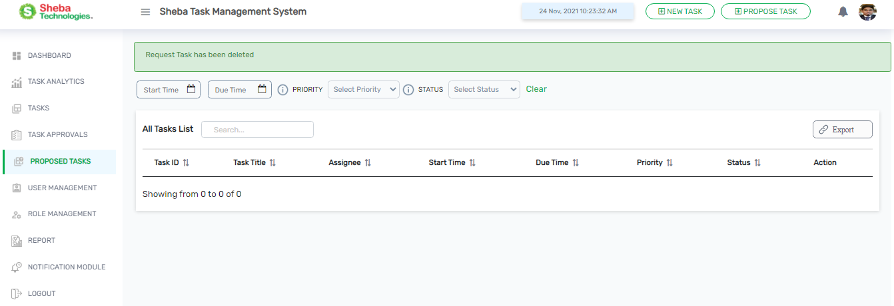After proposing task user can delete the task from **Proposed Task Page**.

Figure 15 Proposed task Deletion (Assignee)

* After deleting a task following message will be shown to the user **Request Task has been deleted**.

# Task Analytics

Clicking on Task Analytics button user will redirected to Task analytics page

Here user will find following sections:

* Over All Task Status.
* Direct Supervisee Status.
* Program Wise Details
  + - Overdue Task Status
    - Overall Task Status
    - Programme Task Details
    - Individual Task Details

## Overall Task Status

Figure 17 Individual Task Details

Figure 16 Overall Task Status Panel

* Here user will find all statistics related to the task that are assigned accepted, In Progress, completed rejected, overdue.
* Here user will find the designated Supervisee status of that user.
* Assigned task details of the Supervisee.

## Program Wise Details

**Program Name**

Figure 18 Program Wise Details

* In this section, user will find program wise details of the supervisee.

### Overdue Task Status

Figure 19 Overdue Task Statistics

* Here user will find the name wise statistical chart of Overdue Task Status.
* In the X axis the employee name, in y axis the number of overdue task.

### Overall Task Status

Figure 20 Statistics of Overall Task

### Programme Task Details

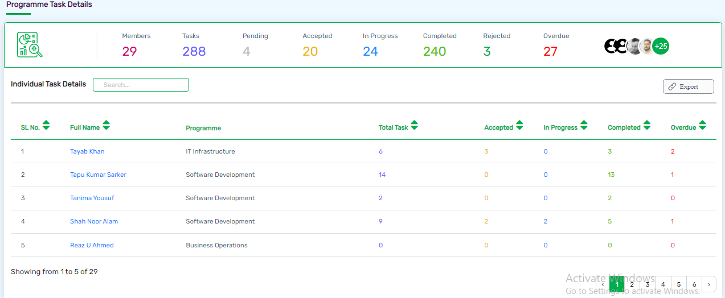

Figure 21 Programme Task Details

* Here user will find statistical details of Programme Task Details.
* Relevant Individual Task Details, Search box, Report generate etc.

# C:\Users\Sheba\Downloads\screencapture-tms-shebatech-bd-tasks-2021-11-23-15_26_26.pngTasks

**Click to**

**Access Next Page**

Figure 24 All Task list Page

**Click to Generate Report**

* Clicking on the **Tasks** form the Navigation button will redirect to All Task List Page

**Status of the**

**Task**

**Click to**

**Delete**

**Task**

**Click To**

**Edit**

**Task**

# Task Approvals

* 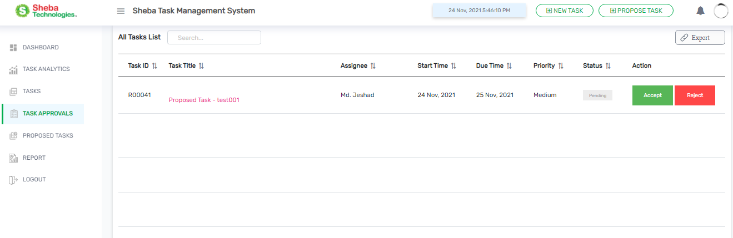 Clicking on the Task Approvals form navigation bar user will redirect to **Task Approvals** page.

**Click to**

**Reject Task**

**Click to**

**Accept Task Request**

Figure 25 Proposed Task List Page

* Here user will find the all the task that are proposed by the designated employee to their respective Line Manager.
* By clicking on the buttons User can A**ccept / Reject** proposed/ requested task from here.

# Proposed Tasks

* Clicking on the Proposed Task Button will redirected Proposed Tasks list page.

Figure 16 Proposed Task List

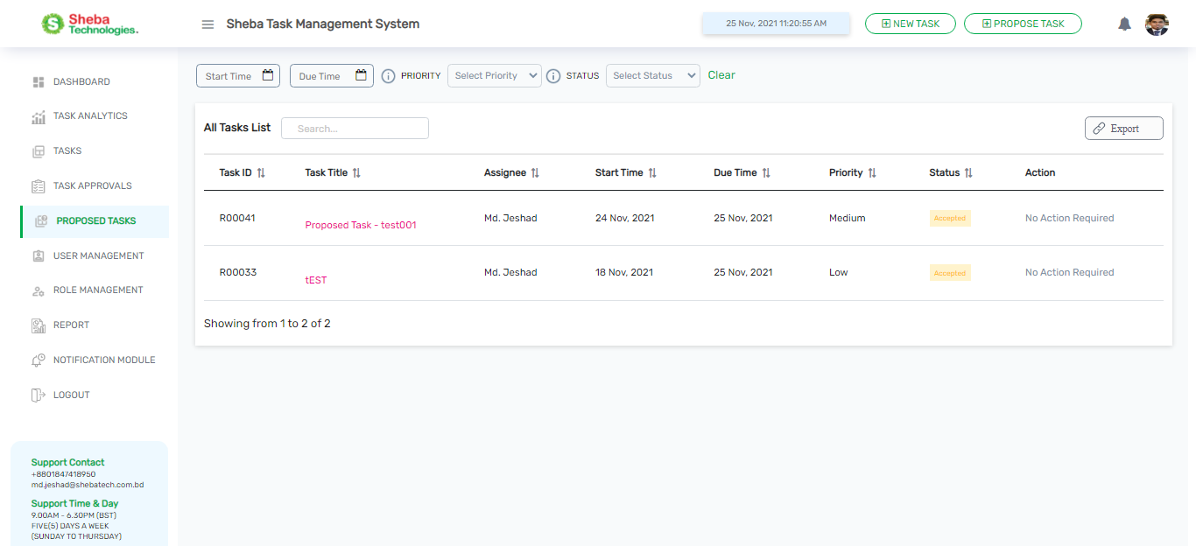

* Here user will find the list of proposed task list of the employee.
* User can find here all details related to proposed task ,status
* User can **Search** **Bar** here using relevant keyword.
* User can generate Report using **Export** Button.

# User Management

* Clicking on User management from the navigation bar, admin will be redirected All User List Page
* This is a super admin feature.

## All User List

Figure 17 All User list (1)

* The user management feature will allow the Admin to create and modify user roles for the system.
* By Clicking on Export (PDF) button, Admin will be able to download all user list details report.
* By Clicking on Edit button, enables admin to modify the specific user information.
* By Clicking on New User button, allows admin to create or register new user.
* 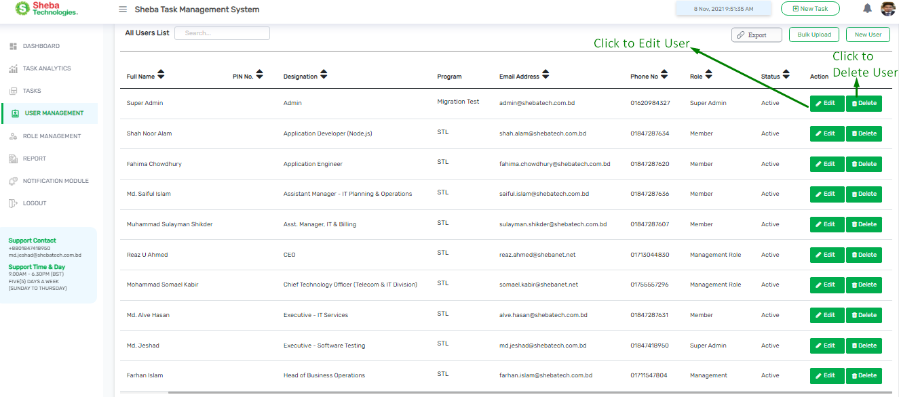By Clicking on Bulk Upload button, enables admin to register user through bulk format.

Figure 18 All User List (2) .

Table 8 All User list Table details

|  |  |
| --- | --- |
| **Column / Field Name /Button** | **Description** |
| **New User** | By clicking on the button admin will be able to create or register new user |
| **Edit / Delete** | Modify the specific User/Delete a specific user |
| **Bulk Upload** | Upload bulk file to register User |
| **Export (PDF)** | Generate report of All User List |
| **Full Name** | Name of the User |
| **Designation** | Designation of the relevant user |
| **Program** | Relevant Program name of the user |
| **Email Address** | Email address of the user |
| **Phone No** | Relevant phone no of the user |
| **Status** | Active or Inactive status of the user |
| **Action** | Click to Edit information of the user , Click to Delete the user |

## Add New User

* 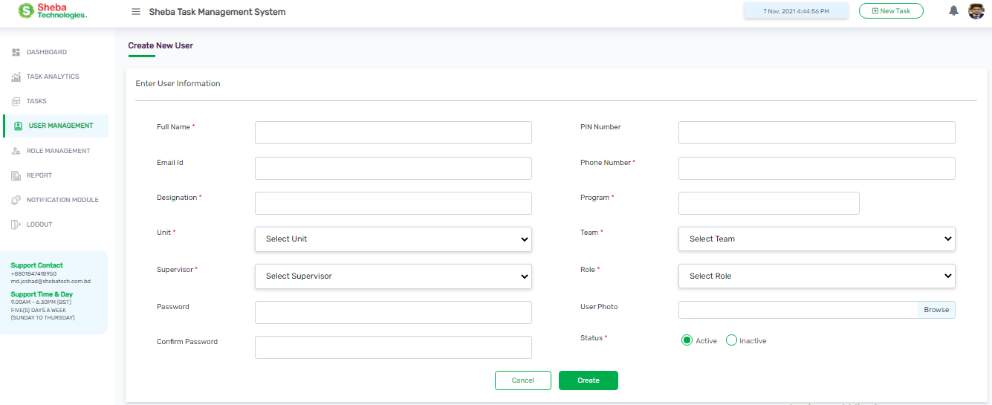Clicking on New User button Admin will redirect to Create New User Page

Figure 19 Create New User Page

* Adding new user will require user’s full name, designation, email address, PIN, password, role unit, supervisor, team, program, phone number and user photo.
* The super admin can then select a role for a new user for a specific role and can determine Activity Status as well;

|  |  |
| --- | --- |
| **Field Name/Button** | **Description** |
| **Full Name** | Enter user full name |
| **Designation** | Enter user designation |
| **PIN Number** | Assign a PIN for the user |
| **Email** | Enter user email address |
| **Phone Number** | Enter user phone number |
| **Password** | Enter a password for user |
| **Confirm Password** | Enter same password to confirm |
| **Role** | Select Role from role data |
| **Unit** | Select Unit from unit data |
| **Supervisor** | Select Supervisor from supervisor data |
| **Team** | Select Team from team data |
| **Program** | Select Program from program data |
| **User Photo** | Browse and upload user photo |
| **Create** | Clicking on the button will create new user |
| **Cancel** | Clicking on the button will close the form. |

Table 9 Create New User Page Details

## Edit User

* Clicking on Edit button from the action column will redirect to Edit User Page;
* Editing a user will give the ability to change user’s full name, designation, email address, PIN, password, role unit, supervisor, team, program, and phone number and user photo.
* 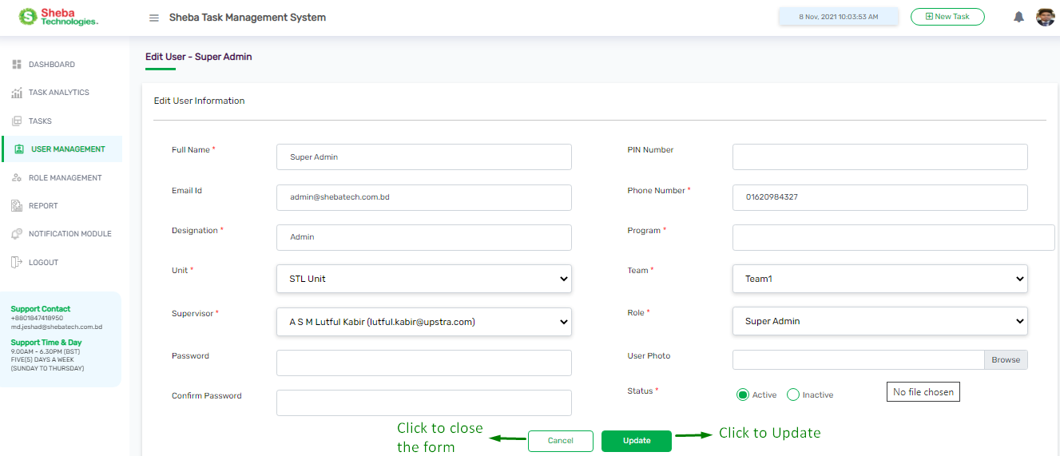The super admin can then change a role for a new user for specific role and can determine Activity Status as well.

Figure 20 Edit User Page

Table 10 Edit User Page Details

|  |  |
| --- | --- |
| **Field Name/Button** | **Description** |
| **Full Name** | Enter user full name |
| **Designation** | Enter user designation |
| **PIN Number** | Assign a PIN for the user |
| **Email** | Enter user email address |
| **Password** | Enter a password for user |
| **Confirm Password** | Enter same password to confirm |
| **Role** | Select Role from role data |
| **Unit** | Select Unit from unit data |
| **Supervisor** | Select Supervisor from supervisor data |
| **Team** | Select Team from team data |
| **Program** | Select Program from program data |
| **Phone Number** | Enter user phone number |
| **User Photo** | Browse and upload user photo |

## Bulk Upload

* 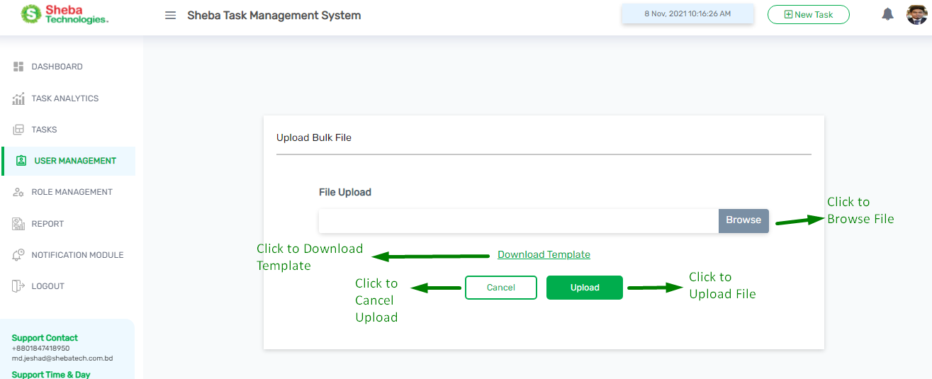Clicking on Bulk Upload button from the User Management Page will redirect to Upload Bulk File Page

Figure 21 Bulk Upload Page

* Admin will be able to upload list of users by use of Bulk Upload. The format is being clarified in the Template

Table 11 Bulk Upload Page Details

|  |  |
| --- | --- |
| **Field Name/Button** | **Description** |
| **Browse** | By clicking on the button user can browse and select file from the local device and upload the file. |
| **Download Template** | By clicking on the button user can download the format of the Bulk file |
| **Update** | Click to update a new users into the user list. |
| **Cancel** | Click cancel to close. |

# Role Management

* Clicking on Role Management Function Admin will redirect to All Role List page.
* 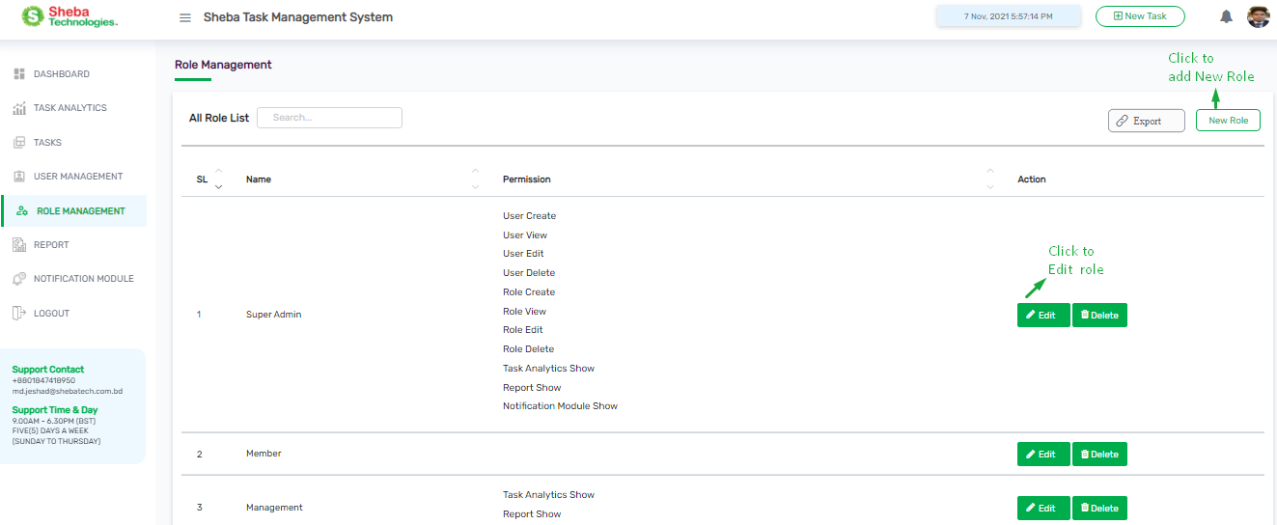Here admin will find Create Role and Edit Role Features. This feature is super admin exclusive.

Figure 22 Role Management Page

## All Role List

* Role List will provide the details of the roles and permission, along with features such as Creating Role, Editing, Deleting and Exporting

Table 12 Role Management Page Details

|  |  |
| --- | --- |
| **Column /Field Name/Button** | **Description** |
| **New User** | Create or register new Role |
| **Name** | Name of the role |
| **Permission** | Relevant Permission for the designated role |
| **Edit** | Modify the specific Role |
| **Delete** | Remove Role from Role List |
| **Export (PDF)** | Generate report of All Role List |

## Create Role

* 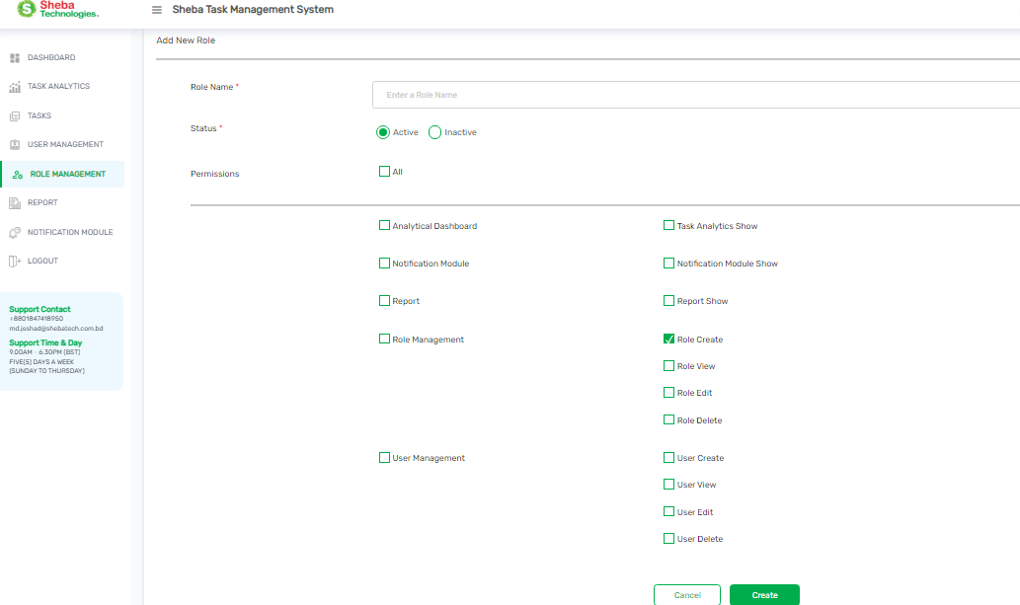Clicking on new role will redirect to Add New Role page

Figure 23 Add New Role Page

* Here user will find relevant information for adding a New Role into the system

Table 13 Add New Role Page details

|  |  |
| --- | --- |
| **Field Name/Button** | **Description** |
| **Role Name** | Enter Role Title |
| **Status** | Select Status between Active & Inactive |
| **Permission** | Select relevant Permission from Permission check box |
| **Create** | Click to create a new role into the role list. |
| **Cancel** | Click cancel to close. |

## Edit Role

Figure 24 Edit Role Page

* Edit Role will provide the user to change roles, permission and status
* Here user will find relevant information for edit a role

Table 14 Edit Role Page details

|  |  |
| --- | --- |
| **Field Name/Button** | **Description** |
| **Role Name** | Rewrite Role Title |
| **Status** | Change Status between Active & Inactive |
| **Permission** | Change Permission from Permission data |
| **Create** | Click to create a new role into the role list. |
| **Cancel** | Click cancel to close. |

# Report Generate

* Clicking on Report Button from the Navigation user will redirect to report generate page

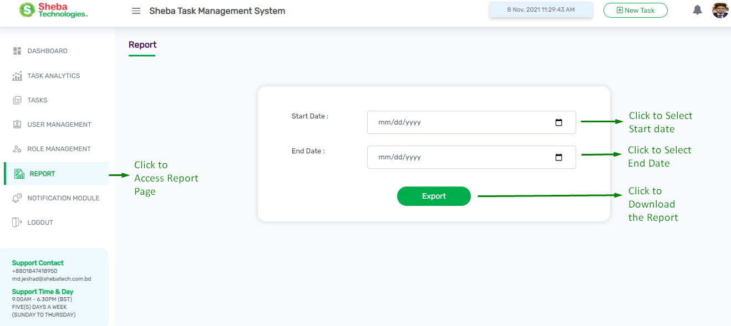

Figure 25 Report generate page

* Here User will find Start Date field and End Date Field, Export button.

Table 15 Report generate page details

|  |  |
| --- | --- |
| **Field Name/Button** | **Description** |
| **Start Date** | Relevant start date for the report |
| **End Date** | Relevant end date for the report |
| **Export** | Click to generate and download the report |

# C:\Users\Sheba\OneDrive\Documents\screencapture-tms-shebatech-bd-notification-module-2021-11-08-12_03_01.pngNotification Module

Figure 26 Notification Module page

* Clicking on Notification module from the navigation bar user will redirect to Notification Module’s All Event List page.
* Here user will find all events name, Email column In APP column, Export button, Update button, Search Box.

Table 16 Notification Page details

|  |  |
| --- | --- |
| **Column/Field Name/Button** | **Description** |
| **Events** | Name of the relevant Event. |
| **Email** | In this column user will find relevant check boxes for any respective event Check / Uncheck will allow that event to send notification via Email |
| **In App** | In this column user will find relevant check boxes for any respective event Check / Uncheck will allow that event to send notification In app |
|  | Clicking on Update button will confirm all relevant changes have been made |
|  | Using relevant keyword in the Search box user will be able to search any information |
|  | Clicking on Export button user will be able to generate relevant report |
| **Checkboxes** | User can check / uncheck boxes for any respective event |

*Thank You*

*For*

*Using TMS*